Using KIM’s annotation facilities
The application of KIM’s semantic annotation facilities on content from a specific subject domain is not that straightforward – KIM has to be ‘prepared’ first for such a task. In particular, the KIM platform has to be extended with knowledge about the new domain through a process consisting of three steps. In the following subsections we briefly explain how we performed these steps when preparing KIM for annotation of learning artifacts related to a certain course. For more general information about this procedure we refer the interested readers to the KIM’s documentation.
Please notice that KIM is neither open-source nor free for commercial usage. However, Ontotext provides it free of charge to registered users for research and evaluation purposes.
Step 1: Extending the KIM’s underlying ontology model with a domain-specific model.
To be able to use KIM’s annotation facilities one has to model the domain specific knowledge (i.e., the domain concepts and their relations) either by instantiating or sub-classing appropriate classes and properties of the PROTON upper-level ontology. This requirement has to be specified if the KIM’s default information extraction module is to be used (it recognizes only instances of the Entity class – the top level class in the PROTON ontology – or one of its subclasses).
The PROTON user guide suggests and provides the rational for using protont:Topic class for representing any sort of a topic or a theme explicitly defined for classification purposes. Even though any other class or entity can serve as a topic, the instances of this class are exclusively those concepts which are intended to be used as subject topics. Typically, these instances are used as values of the dc:subject property. Since we intended to annotate learning artifacts with domain topics we followed the recommendations of this user guide. Accordingly, we used the protont:Topic class for modeling domain topics of a course: the domain topics are modeled as instances of the protont:Topic class, and the topics hierarchy is established (i.e., is-a relation between topics) by relating the generated instances via the protont:subTopicOf property (this property is not the same as the rdfs:subClassOf (meta)property, for explanation see the PROTON user guide). We only introduced hasPart as an inverse property of the protont:isPartOf property, in order to more easily manage the aggregation relations between the domain topics.

Step 2: Extending the instance base with pre-populated entities important in the new domain
For each important domain entity it is required to add its aliases (nicknames), i.e. the terms and/or phrases that originated along the line of frequent references to these entities. In our case, these entities are domain topics represented as instances of the protont:Topic class. This is done by assigning one or more instances of the psys:Alias class (via psys:hasAlias property) to each entity (i.e., topic). To represent the official or the most popular name of an entity, the psys:MainAlias class and psys:hasMainAlias property should be used. It is also vital to state that each entity is a trusted entity, i.e., that the entity is generated by a ‘trusted source’. This is done by linking the entity via the psys:generatedBy property to an instance of the psys:Trusted class. The reason for adding these statements is that during the phrase-lookup (gazetteer) phase of the information extraction process, the gazetteer looks up only the mentions of the trusted entities (this is done to prevent the propagation of one-time information extraction mistakes).

Step 3: Changing or extending the KIM’s module for information extraction
This is an optional step on which we are currently working on in order to improve the annotation of learning resources.
After the annotation process is finished, each item of learning content – lesson, forum posting or chat message – is assigned zero or more semantic annotations. In terms of ontological representation, each instance of the ContentItem class is assigned (via the hasSemAnnotation property) zero or more instances of the SemAnnotation class (see Figure 1). The later class has two properties: the dc:subject property and the rdfs:label property. The value of the former property is a domain concept, i.e., the URI of the appropriate protont:Topic instance. The latter property is a human readable label of the domain topic given in the dc:subject property.
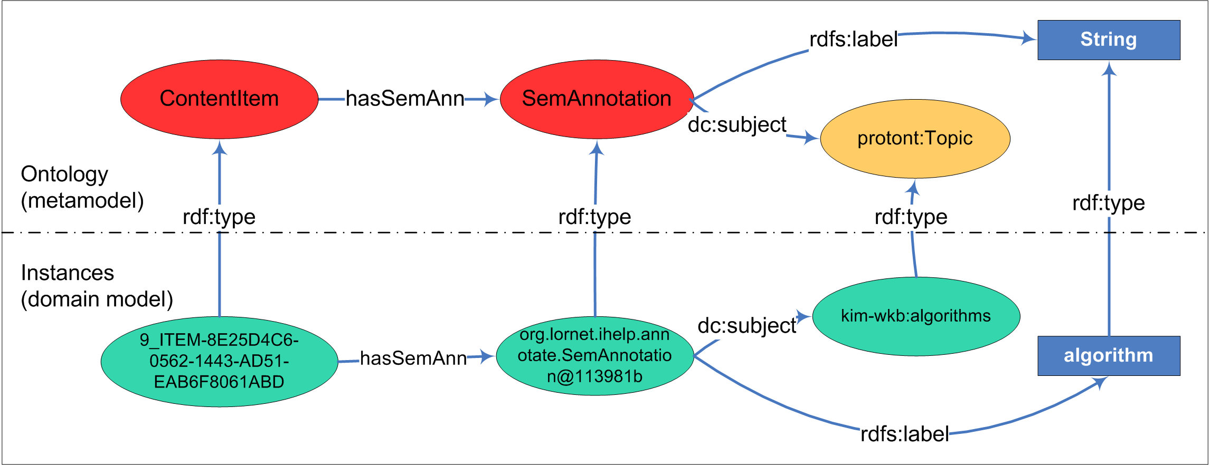
Figure 1. The representation of semantic annotations of content items in the LOCO framework
Please note that the ontologies of the LOCO framework have been restructured recently, but LOCO-analyst still works with the previous version described here.

http://www.ontotext.com/kim/doc/sys-doc/index.html
http://proton.semanticweb.org/
http://proton.semanticweb.org/D1_8_1.pdf
protont stands for the namespace of the Top module of the PROTON ontology (http://proton.semanticweb.org/2005/04/protont)
dc stands for the namespace of the Dublin Core metadata schema (http://pur1.org/metadata/dublin-core)
psys stands for the namespace of the Proton System module of the Proton ontology (http://proton.semanticweb.org/2005/04/protons)
The classes and properties without the prefix belong to the Learning Context ontology
kim-wkb stands for the namespace of the KIM’s ‘working knowledge base’, i.e. repository of ontological instances (http://www.ontotext.com/kim/2005/04/wkb)

